Lab 4.8 Assignment

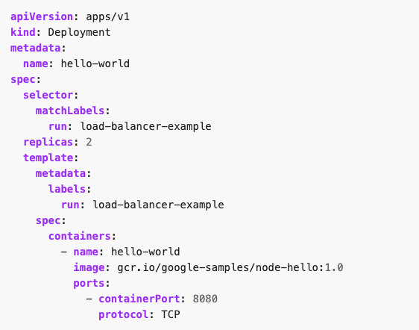

- Run a Hello World application in your cluster: Create the application Deployment using the file above:

kubectl apply -f <yml file>

- Display information about the Deployment:
kubectl get deployments hello-world
kubectl describe deployments hello-world

- Display information about your ReplicaSet objects:
kubectl get replicasets
kubectl describe replicasets

- Create a Service object that exposes the deployment:
kubectl expose deployment hello-world --type=NodePort --name=example-service

- Display information about the Service:
kubectl describe services example-service

Make a note of the NodePort value for the service. For example, in the preceding output, the NodePort value is 31496.

- List the pods that are running the Hello World application:
kubectl get pods -o wide

- Use the node address and node port to access the Hello World application:
curl http://<public-node-ip>:<node-port>
where <public-node-ip> is the public IP address of your node, and <node-port> is the NodePort value for your service. The response to a successful request is a hello message:
Hello Kubernetes!

- To delete the Service/ Deployment, enter this command:
kubectl delete services example-service
kubectl delete deployment hello-world

